Training Guide for Sales and Customer Support

## Background:

* + 3% of Indian engineering students are not employable for new age jobs.
  + Problem Statement: Job descriptions do not clearly communicate the skill requirements for jobs.
  + Product Goals: Segregate Jobs based on skill requirements and make the learning’s of those skills available through the platform. So that we recommend and students apply jobs which are relevant for them.

## Market background:

Write a short description of your market and audience:

* + Our target users are recent graduates searching for jobs. They are learning skills from different platform; apply to jobs through job boards.
  + Describe your targeted market: where you would like to roll out your product, anything specific sales need to know.
  + We would like to roll out this product to recent graduates from tier 2 and tier 3 colleges.
* Our competitors are Freshersworld.com, internshala, offcampusjobsforu.com.

## Product Background:

Describe your product and what sales need to know about it:

* Three features are My Goals, Group by and Auto connections. My goals helps graduate to find their skill gap, Group by allows them to group opportunities based on similar skill requirements and industry. Auto connections allow users to build connections based on similar aspirations of user.

### Key Features

Feature 1: **Auto connections**: Initial level connections will built with other recent graduates who are aspiring for Job roles. Now it’s up to job applicant to decide if he wants to convert into a professional connection.

Feature 2: **Skill gap depicter:** It fetches skill requirements from posted job descriptions and mapped it with LinkedIn learning product. It motivates the students to acquire requisite skills for the Job.

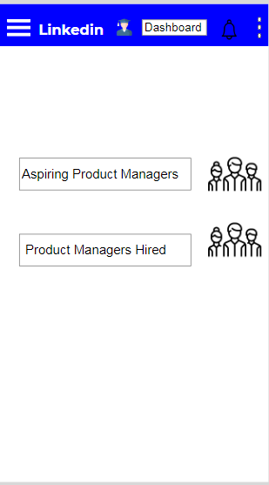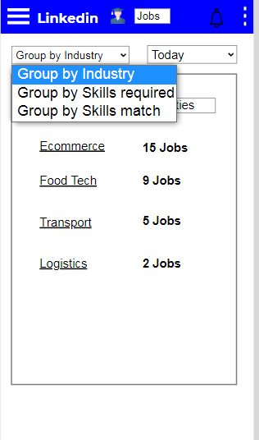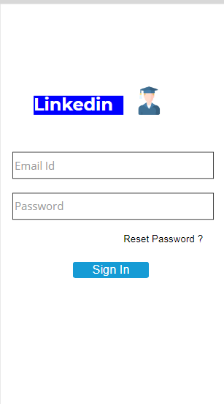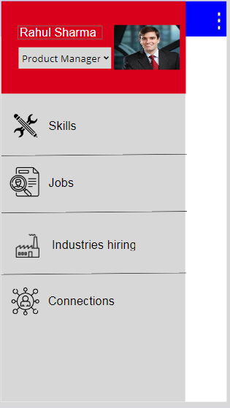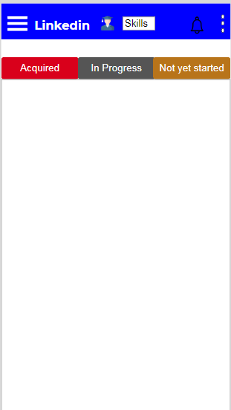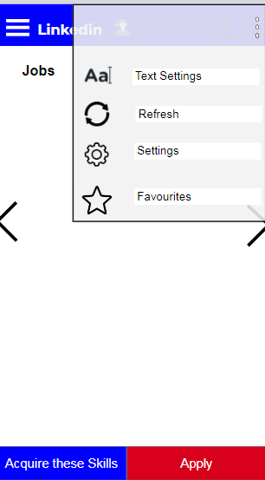

## Pricing:

Describe your pricing:

* Access to LinkedIn learning is chargeable at 1400+tax /month.
* First month access is free, thereafter it is chargeable

## Benefits to the user:

User will be able to identify with respect to current jobs in market ,acquire those skills and apply to jobs based on their preferences.

## How to use the product

Detailed mock ups are provided in the features section. They are accessible through mobile app and website. URL: <https://ciwxvs.axshare.com/>

## Where users can find the product

Users can download the app from app store or find a downloadable link through website.